REVISIONS

REV # | ECN # | Description of Change | Engineer | Approved | Date
1 |  | New Document

Description

Firmware Upgrade Development Process

Contents
1.0 INTRODUCTION AND OVERVIEW 3
1.1 Purpose 3
1.2 Responsibility 3
1.3 Definitions and Acronyms 3
1.4 References 3
1.5 Product Overview 3
2.0 Firmware Upgrade Process 3
2.1 USB DFU 3
2.2 ROM Bootloader 3
2.3 Flash Bootloader 4
3.0 SMC Software Tool 4
3.1 LM Flash Programmer 4
3.2 DFU Util 5
3.3 GUI 5
4.0 Firmware Generation Process 6
4.1 CCS – Flash Bootloader Project Configuration 6
4.1.1 Linker File 6
4.1.2 Build Steps 7
4.1.3 Configure Flags 7
4.2 CCS – Application Configuration 7
4.2.1 Linker File 7
4.2.2 TI-RTOS Config 7
4.2.3 CRC Header 8
4.2.4 Linker File Section 8
4.2.5 Build Steps – Generate .bin file 8
4.2.6 Build Steps – Generate binary file with CRC 9
4.2.7 Erase Segments Only 9
4.3 Conclusion 10

INTRODUCTION AND OVERVIEW

Purpose

Responsibility
The Design Engineer responsible for the product is responsible to keep this document accurate and make sure that all engineers working on various aspects of the product always have the latest copy to work from.

Definitions and Acronyms

References

Product Overview

Firmware Upgrade Process
For ease of programming, the firmware upgrade process will be implemented over USB. In this way, the operator does not need a JTAG emulation tool to download the firmware to the device. The operator should be able to download the original firmware, or upgrade it at a later time, using a simple USB cable. The above is implemented using the standard Device Firmware Upgrade class of the USB standard.

USB DFU
USB Device Firmware Upgrade (DFU) is an official USB device class specification of the USB Implementers Forum. It specifies a universal independent way of updating the firmware of a USB device. The idea is to have a unified, vendor-independent, firmware update tool as part of the device firmware. This tool can be use to both download a new firmware to the device or upload the existing firmware from the device.

ROM Bootloader
The TI simplelink family of microcontrollers has an integrated bootloader housed inside the ROM. This ROM-based boot loader is executed each time the device is reset when the flash is empty. The flash is considered empty if the first two words are all ones. When run, it will allow the flash to be updated using one of the following interfaces:

- UART0 using a custom serial protocol
- SSI0 using a custom serial protocol
- I2C0 using a custom serial protocol
- USB using DFU protocol
For the purpose of this document, we are only interested in the the USB portion of the boot loader.

Flash Bootloader
The ROM bootloader has a limited set of functionalites, in most applications a second stage bootlaoder is desired. The second stage bootloader can implement advanced features such as encryption and cyclic redundancy check. Encryption is used to verify that the firmware originated from a verified source, while cyclic redundancy check is used to avoid application firmware corruption.

Although the flash bootloader used can support both encryption and CRC checking, only the CRC feature is currently enabled. Since the device will be programmed only on-premise, the encryption feature has been put on hold for future releases.

SMC Software Tool
The SMC software tool should be used for programming the device. The SMC implementation takes advantage of two external 3rd party tools : LM Flash Programmer and dfu-util.

LM Flash Programmer
LM Flash Programmer is a free flash programming tool from Texas Instruments. It can be used to download a firmware image to the device. It is assumed that LM Flash Programmer is already installed on the client PC. LM Flash Programmer can be downloaded from TI website on the following link https://www.ti.com/tool/LMFLASHPROGRAMMER.

LM Flash programmer is used to download and upload firmware images to and from the device. The below commands show how to use LM Flash programmer to accomplish this.

Download firmware to the device:
lmflash.exe -i USB -r -c -o 0xXXXX binfile.bin

-r: optional flag to reset the device after download
-c: optional flag to verify the flash after download
-o: to pass the starting address of the internal flash memory location where the image will be downloaded to. Should be 0x0000 for bootloader and 0x4000 for application
binfile.bin: fullpath of the image to be downloaded to the device

DFU Util
dfu-util is a host side implementation of the DFU 1.0 and DFU 1.1 specifications of the USB forum. DFU is intended to download and upload firmware to/from devices connected over USB. Using dfu-util you can download firmware to your DFU-enabled device or upload firmware from it.
Dfu-util is bundled with the installation of the SMC. In this application, it is used to list the attached USB devices that are in dfu mode.
Execture the below command to list attached USB devices that are in DFU mode:
dfu-util.exe -l
dfu-util can be downloaded manually from the following link https://sourceforge.net/projects/dfu-util/, it should be placed next to the SMC tool executable. The SMC tool installer will automatically install dfu-util in the correct location.

GUI
The GUI is very simple to use. If it is the first time to program the device, the device will automatically enumerate as a dfu device in the device manager panel. Otherwise, the old application will be running and the user will need to connect to it using COM port to issue the reprogram command.

Step 1:
If case old application is running choose the corresponding COM port from the combo-box shown below. If the port is not showing, click update. If first time programming device, skip this step.
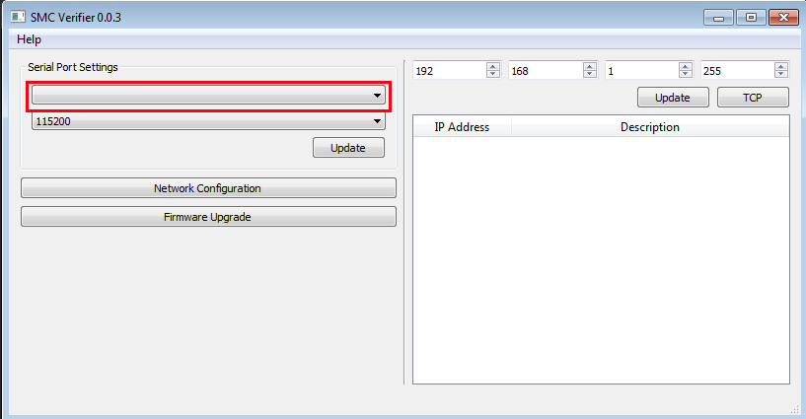

Step 2
If case old application is running choose the corresponding baudrate from the combo-box shown below (should be 115200). If first time programming device, skip this step.
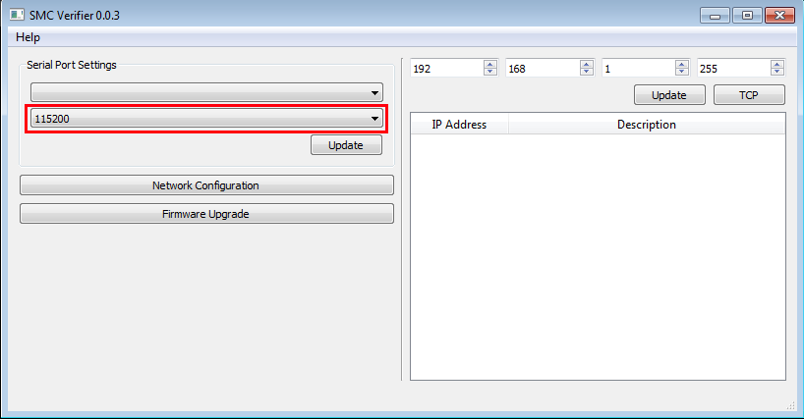

Step 3
If not automatically detected, browse to the lmflash.exe path located in the LM Flash Programmer installation directory.

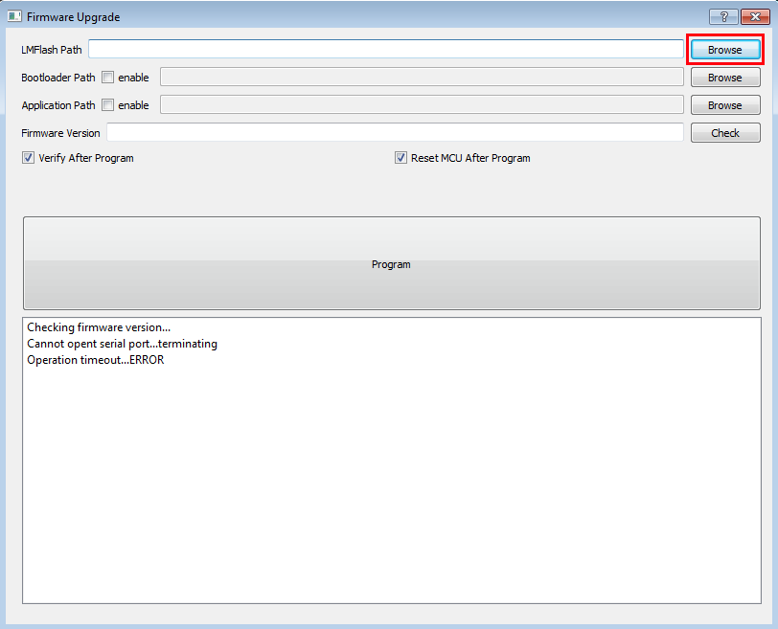
Step 4
Based on requirement, browse to one (or both) of the bootloader and application images. Then click the program button. You should see the progress in the logging text area.

Step 5
Click Check button next to the firmware version to make sure that the device now has the newer application version.

Firmware Generation Process
The binary files for both the bootloader and the application are generated using Code Composer studio. A single time project configuration should be done to ensure the correct generation of these binary files. Once this configuration is done, the binary file can be found in the corresponding build folder.

CCS – Flash Bootloader Project Configuration

Linker File
The memory reserved for the bootloader is from address 0x0000 till address 0x4000. This should be reflected in the linker file:
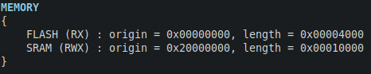

Build Steps
The build steps should include the command that takes the .out file from the output folder and generate the binary file. To update the build steps, go to project properties and add the below command under post build steps
"${CCE_INSTALL_ROOT}/utils/tiobj2bin/tiobj2bin" "${BuildArtifactFileName}" "${BuildArtifactFileBaseName}.bin" "${CG_TOOL_ROOT}/bin/armofd" "${CG_TOOL_ROOT}/bin/armhex" "${CCE_INSTALL_ROOT}/utils/tiobj2bin/mkhex4bin"

Configure Flags
The bootloader configuration is done using the bl_config.h file. Multiple flags must be defined to configure the project:
#define CHECK_CRC : Enable CRC check
#define ENFORCE_CRC : Stay in bootloader if CRC is wrong
#define APP_START_ADDRESS 0x00004000 : Application start address
#define USB_ENABLE_UPDATE : Enable update using USB
#define ENABLE_BL_UPDATE: Enable updating the bootloader itself
#define FLASH_RSVD_SPACE 0x00020000: Reserved NVM lash area

CCS – Application Configuration

Linker File
The application should start at address 0x4000 and end at address 0x0020000. This should be reflected in the linker file.

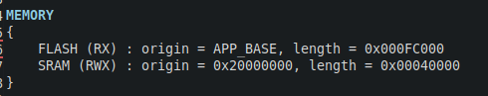
TI-RTOS Config
TI-RTOS must be configured to store the reset vector table at the new application start address of 0x4000 instead of address 0x0000. This is done by adding the following line to the TI-RTOS configuration file.
m3Hwi.resetVectorAddress = 0x00004000;\

CRC Header
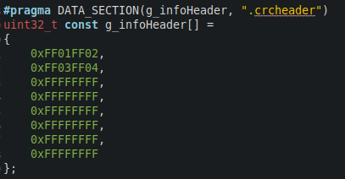
Metadata should be stored within the application image, this metadata is used by the bootlaoder to compare the calculated CRC with the stored CRC. This metadata should be stored in an array and is surrounded by magic numbers. Add the below array to the application:

Linker File Section
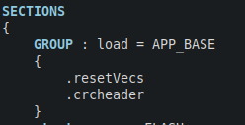
The above mentioned array should be stored directly after the reset vector table in memory. To do so, add the below on top of the Sections area in the linker file.

Build Steps – Generate .bin file
The build steps should include the command that takes the .out file from the output folder and generate the binary file. To update the build steps, go to project properties and add the below command under post build steps
"${CCE_INSTALL_ROOT}/utils/tiobj2bin/tiobj2bin" "${BuildArtifactFileName}" "${BuildArtifactFileBaseName}.bin" "${CG_TOOL_ROOT}/bin/armofd" "${CG_TOOL_ROOT}/bin/armhex" "${CCE_INSTALL_ROOT}/utils/tiobj2bin/mkhex4bin"

Build Steps – Generate binary file with CRC
Binpack is a utility provided by Texas Instruments. The purpose of this utility is to take a raw binary file generated in the previous step and append the calculated CRC to the corresponding location inside the header array mentioned previously. To implement this command inside CCS, the binpack utility has been placed inside the Tools folder and a call for this utility is done using the project post build steps as shown below.
"${PROJECT_LOC}/Tools/Linux/binpack" -i "${BuildArtifactFileBaseName}.bin" -o update.bin -a 0x4000 -x

Erase Segments Only
To enable the debugging feature inside Code Composer Studio. The project must be configured to erase only thre necessary segments. Otherwise the bootloader will be erased everytime a debugging session is launched. In the project properties window, go to the Debug menu and under “MSP432 Flash settings” select “Erase and download necessary segments only”.

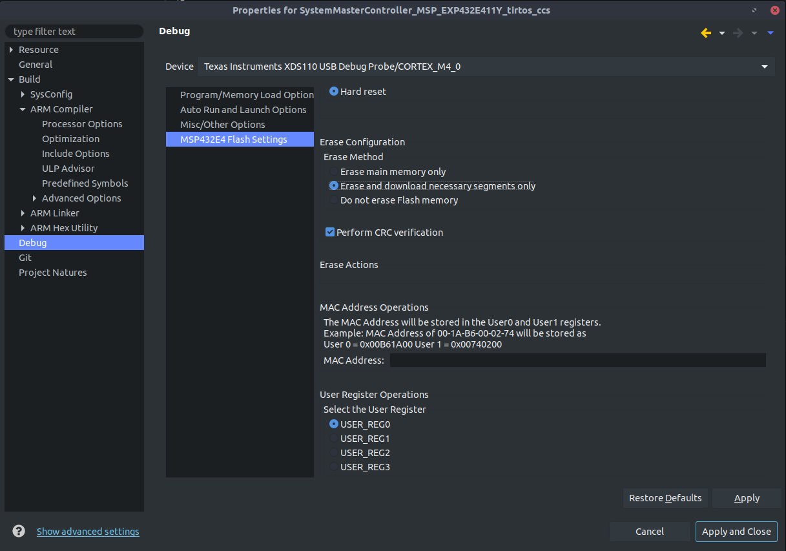

Conclusion
If everything was done successfully, each project will have .bin files in the corresponding output folder. The bootloader project will only have one .bin file in the output directory and it can be used with the SMC flash programmer tool. The application project will have 2 files in the output directory, only the “update.bin” file can be used with the SMC flash programmer utility.

